ROYAL PALM OWNERS ASSOCIATION
Minutes of Committee Meeting held on Friday 26th September 2025 at 9.30am in the Owners Office.

PRESENT
Gary McEwan President
Eladio Administrator
Iain Paterson Treasurer
Josie Thomas Committee Member
George Surridge Committee Member (Virtual)
Gina Lanz Committee Member (Virtual)
Anne Mederos Complex Co-ordinator / Head of Reception

Apologies received from Etelina

- Approval of minutes 26th June 2025 Approved


- The action plan from 26th June was discussed and updates made on matters now concluded, work in progress and new actions for the future. Most key items appear in the agenda for today. Refreshed Action Plan available in the owner’s office.

3. Administrators Update
- With the historical administration of Inversiones Oasis, a sale of their parking spaces seemed likely. The passage of time now suggests that this is unlikely to come to pass and will be removed as an agenda item until something materially changes.

- Inversiones Oasis remain a significant debtor. They have been keeping up with ongoing bills as they fall due but there remains a legacy of debt. Payments to the agreed payment plan have been ‘sporadic’. Eladio will keep the pressure on. There are a few owners also behind with sums owed but the amounts and the durations involved do not give us significant concerns.

- The Committee discussed the ongoing saga of the unauthorised campsite development adjacent to Royal Palm. We are aware that this is causing significant distress to owners, particularly those who have it as their vista. We can assure owners that while there is not much that can be done given it is privately held land; we are keeping the pressure on the Local Authority to do all they can to clean this area up. We would urge owners individually, who feel strongly about this to press hard on an individual level, such that the collective unrest is felt by those in authority. Information of how to write to the Mayors’ office is available from Anne.

- The Committee discussed some of the changes to the movement of people around the world. The new ‘European Entry/Exit System’ (EES) is approaching and the apparent tightening of the rules around the ‘Carta de Invitacion’ for those visiting. The UK and European media is full of articles about how these changes will be introduced. The role of the Committee is not to provide legal advice on these matters as the information available tends to be vague and open to interpretation, but we would urge all owners to be aware of how changes to the rules may affect them and use their own judgement when acting.

4. Financial Report 25/26
Iain brought us up to date with a comprehensive overview of the current financial position. While we are currently showing a deficit, this has been planned. We were carrying a significant surplus (€90k) from previous years and this year we have been reducing this to what we would consider a more normal surplus around (€40k). Large scale costs include the pool deck refurb, the office refurb, the new pool heater and additional poolside furniture. With this work now complete, the complex is looking well and cared for.
Our ‘Special Projects’ fund has also been used to raise the wall heights to a safer level around the complex and to create 2 new storage rooms that will generate recurring revenue. The wall height project remains ongoing as we work our way around the estate.

5. Maintenance Report/Planned Projects 2025 Unplanned emergency work
With major works behind us for the moment, the team are back to more general maintenance projects. The RP perimeter wall that faces El Mirador has been suffering from dampness coming through from the gardens. These areas are being stripped back, treated, rendered and painted. This work is current. The wooden benches are being repainted and varnished and other general maintenance is underway.
Moises provided us with an update. Afterwards we expressed our gratitude for the outstanding work of our on-site maintenance team. They are diligent, responsive and give us great value for the investment in them.

We have several septic tanks positioned discreetly around the complex and one of these is starting to leak very slightly. Fernando, our architect will work with us to replace this tank. The cost of this is not thought to be onerous.
As we reported at the last meeting, we have an issue with a 35-year-old water pump, which provides a pressure boost during low-flow situations. We have approved a replacement pump at a cost of c€8k. We have 2 water systems. One recently installed that services our water needs (other than our homes) and one that directly supplies our homes. The new and the old pumps are illustrated here. Our architect will oversee the modifications required to accommodate the new equipment.
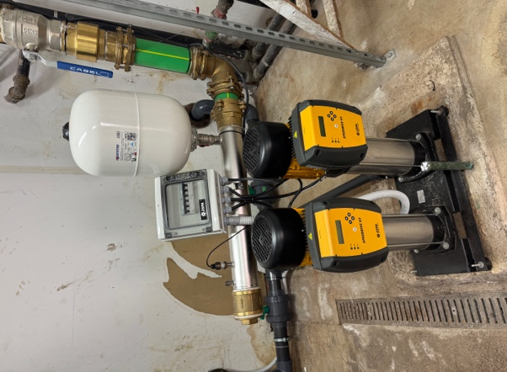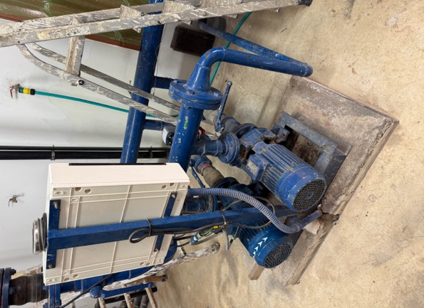
6. Contracts/Licence applications/insurance claims 2025.
The Committee reviewed, with Anne, the contracts we have in place with service providers. Everything is in place and running smoothly. We have a locale for rent beside the Owners Office. It was previously occupied by the Ambulance service. An interested party is now in negotiations with us. A commercial deal is being structured that would allow for some property improvement to be undertaken and the costs shared over time and reflected in the rental agreement. Our architect is examining the possibilities, and we will report on progress.

7. Staffing Issues/Sickness/Holidays
After a period off, Fabio has returned to work.
Sadly, for work/life balance reasons Sarai is leaving her post as lifeguard on the 8th October. We are very sad to see her go but understand her reasoning. We have wished her well and her replacement is being recruited as we speak. Antonio, the lifeguard who works at the weekend is also leaving through retirement at the end of October and so we are looking at a whole new pool team. The Committee has asked Anne to speak with proposed new staff to ensure they are in alignment with Royal Palm expectations. We have asked Jose Luis to pass on our thanks and best wishes to both Sarai and Antonio.

For some time, a proposed law change was being looked at that would have significantly reduced the working week but this appears to no longer be proposed and so we have removed this from our considerations.

8. Blue Vert Report.
The Committee reviewed the latest Blue Vert report and met with Jose Luis to discuss current operations. Both gardening and cleaning are progressing well although the frequent Calima’s put strain on the team given the thick blanket of dust that covers everything. The palm trees are due to be cut early Oct and ongoing redesign work is a joint effort between the BV team and our team who are always looking at potential improvements to the aesthetics of our complex. The Committee, Anne, Jose Luis and Moises from our maintenance team completed a walk around after the meeting to note areas that require attention. We thanked Jose Luis and the Blue Vert team for stepping in when additional support is needed.
Pool Deck Etiquette: Please note that once the pool is closed, the deck area is not to be used as a social space in the evening, to respect nearby residents. The pool deck always remains a thoroughfare for movement.
Over the summer there was one incident where a guest was not abiding by rules and subsequently responded aggressively to staff when adherence to rules was requested. We have requested the Oasis Management not allow these guests to return but their cooperation in this matter is as much as we can ask for.
Smoking Restrictions: This item is still in the pre implementation phase, but new government legislation will soon prohibit smoking in all communal areas, including pool, terrace and common areas. This new law appears to apply equally to all forms of smoking including vaping. Once in effect, smoking will only be permitted within private apartments and their patio area.

9. Incident/Health/ Safety/Security/ ANTEA (ex-MGO)
During a busy summer there were a few slips, trips and injuries. Whilst regrettable, these have all been responded to and handled well with no need to report anything specific. We continue to prioritise the wellbeing of our residents, guests, and staff.
In our underground car park, 3 cars were vandalised that all belong to a car rental company. They have requested CCTV be installed in that area but in accordance with our previous policy line, we are unable to install CCTV on the complex but we would urge vigilance at all times so that the security of our perimeter stays intact.
All staff have had their annual medicals, and Anne is going on an course in November to keep updated on health, safety and wellbeing.
To address concerns around traffic safety near the Owners Office, we have introduced a 10km/h speed limit to our internal road, supported by signage. With pedestrians, prams, and mobility scooters in regular use, extra care is essential.
10. TV / WiFi

The upgraded WiFi system is mostly installed now. The task was large but worked very smoothly with a good working partnership between the Owners Office and Oasis Management who together made a complex logistics exercise seem efficient. Feedback on the new service seems universally very good with speed and reliability greatly improved. Some owners report their routers running hot. According to PH Electronics, the routers have mainly metal rather than plastic parts and therefore being hot is considered normal. Additionally, some owners have assumed they have WiFi issues when a TV outage occurs. Before calling PH, owners are requested to use a mobile phone or tablet to go to YouTube and insert ‘Video 4k Test’. If you can play a 4k video, the Wifi is working, and the issue is likely to be TV related.
Some payments for these installations remain outstanding so could you please speak to Anne to complete payment please.
George was asked to undertake a review of the TV services we have. His report was comprehensive. There are options available on additional channels, but these come at a cost both in hardware requirements and subscription charges. We plan to consider these options and understand better the usage of these channels compared to those using IPTV or other subscription services such as Netflix. We will take this action forward.
Finally, it perhaps escapes your notice but we have an enormous and redundant satellite dish that sits on the roof in the vicinity of the Owners Office. We have received a very reasonable quotation from PH to have it safely removed and disposed of (€245) and so we have authorised it’s removal prior to the potential of high winds in the winter dislodging it.
11. Owners Issues / Apartment Changes / Alterations and Renovations.
We’ve asked the Administrators to follow up on several items:
- The unauthorised campsite remains the most pressing owner concern
- Blocked and overflowing drain at the OTIS corner
We are pleased to report that previous requested actions have been completed including
- Slippery pavement near the former Balti Balti has been treated with a non slip coating
- New signage is in place to try to stem the flow of unauthorised use of underground parking spaces

Alterations&Inspections:
We continue to review and approve apartment change requests. Please remember that all changes must follow the correct application process. Anne is available to guide owners through this.
A list of current requests and inspection statuses is held in the office. It’s vital that all work aligns with our community statutes, ensuring consistency and safety across the complex.
- Current list of changes receiving final sign off

Apt 45 – Main door replacement
Apt 9 – Doors and windows replaced
Apt 129 – Privacy blind installed

- Proposed changes where approval given and work is pending

Apt 25 – Install new bathroom window
Apt 61a – Install new window and doors

May we remind all owners to please follow the correct procedure when planning any sort of refurbishments, replacements or additions etc to their property. If you are in any doubt, Anne in the Owners Office will be very happy to provide advice and guidance.
There are no exceptions to this as conformance to the statutes, rules and regulations is a foundation stone of the Royal Palm Owners Association

12. In the interests of harmony…….
In this section of our minutes, this aims to highlight areas where neighbourly consideration helps maintain our peaceful environment.
As our properties mature, upgrades become an exciting prospect but with upgrades comes noise. Please be mindful of this and use the normal working day for the noisy jobs. Avoiding noisy early mornings, evenings and Sundays is thoughtful, thanks.

13. Tourism/Renting/Oasis management
Owners are reminded once again that ‘income generating letting’ directly to tourists and holidaymakers in not permitted other than through the sole letting agent. Allowing family and friends to use your apartment is permitted. It is one of our 4 key statutes and should be followed closely as the penalties can be severe.

14. Any other Business
As a reminder to owners, by the end of November 2025, current Committee members will state their intention to stand or step down from office at the 2026 AGM. We will inform you early Dec in the minutes of the November Committee meeting. Owners who wish to be considered for a place on the Committee have until the end of December to state their intentions.

15. Date and Time of next meeting.
November Committee meeting – Thursday 25th November 2025 - 9.30am in the Owners Office

We thank all owners for their continued engagement and cooperation. Your support enables the Committee and staff to ensure Royal Palm remains a beautiful, safe, and welcoming place for all.
Warm regards,
Gary and The Royal Palm Owners Committee

